**DLD Lab 10**

(Software)

23K-2001  
Muzammil Siddiqui  
BCS 2-J

**Exercise#01:**

|  |  |  |  |  |  |  |  |  |  |  |  |  |
| --- | --- | --- | --- | --- | --- | --- | --- | --- | --- | --- | --- | --- |
| Inputs | | | | | | | | | Outputs | | | |
| **D7** | **D6** | **D5** | **D4** | **D3** | **D2** | **D1** | **D0** | **A2** | | **A1** | **A0** |
| 1 | 1 | 1 | 1 | 1 | 1 | 1 | 1 | 1 | | 1 | 1 |
| 1 | 1 | 1 | 1 | 1 | 1 | 1 | 0 | 1 | | 1 | 1 |
| 1 | 1 | 1 | 1 | 1 | 1 | 0 | X | 1 | | 1 | 0 |
| 1 | 1 | 1 | 1 | 1 | 0 | X | X | 1 | | 0 | 1 |
| 1 | 1 | 1 | 1 | 0 | X | X | X | 1 | | 0 | 0 |
| 1 | 1 | 1 | 0 | X | X | X | X | 0 | | 1 | 1 |
| 1 | 1 | 0 | X | X | X | X | X | 0 | | 1 | 0 |
| 1 | 0 | X | X | X | X | X | X | 0 | | 0 | 1 |
| 0 | X | X | X | X | X | X | X | 0 | | 0 | 0 |

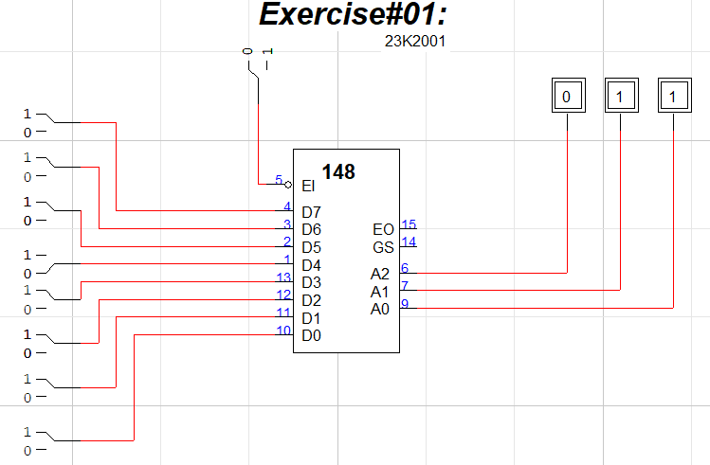Truth Table for Octal to Binary Priority Encoder by Using 74148 IC

**Exercise#02:**

Truth Table for Decimal to BCD Priority Encoder by Using 74147 IC

|  |  |  |  |  |  |  |  |  |  |  |  |  |  |
| --- | --- | --- | --- | --- | --- | --- | --- | --- | --- | --- | --- | --- | --- |
| Active LOW Decimal Inputs | | | | | | | | | Outputs | | | | |
| **1’** | **2’** | **3’** | **4’** | **5’** | **6’** | **7’** | **8’** | **9’** | **Q3** | **Q2** | **Q1** | **Q0** |
| 1 | 1 | 1 | 1 | 1 | 1 | 1 | 1 | 1 | 1 | 1 | 1 | 1 |
| X | X | X | X | X | X | X | X | 0 | 0 | 1 | 1 | 0 |
| X | X | X | X | X | X | X | 0 | 1 | 0 | 1 | 1 | 1 |
| X | X | X | X | X | X | 0 | 1 | 1 | 1 | 0 | 0 | 0 |
| X | X | X | X | X | 0 | 1 | 1 | 1 | 1 | 0 | 0 | 1 |
| X | X | X | X | 0 | 1 | 1 | 1 | 1 | 1 | 0 | 1 | 0 |
| X | X | X | 0 | 1 | 1 | 1 | 1 | 1 | 1 | 0 | 1 | 1 |
| X | X | 0 | 1 | 1 | 1 | 1 | 1 | 1 | 1 | 1 | 0 | 0 |
| X | 0 | 1 | 1 | 1 | 1 | 1 | 1 | 1 | 1 | 1 | 0 | 1 |
| 0 | 1 | 1 | 1 | 1 | 1 | 1 | 1 | 1 | 1 | 1 | 1 | 0 |

**Exercise#03:**

16 bit Octal to Binary Priority Encoder using 74148 IC

**Exercise#04:**

MCQS

1. A
2. A